EXPERMIENT-1-Flight Booking System
Aim:
To develop a cloud-based flight booking system using Zoho Creator for managing passenger and reservation details.
Procedure:
- Created a new application and designed Passenger and Flight forms to store details.
- A Booking form was created using lookup fields to connect passengers and flights.
- Required fields like date and status were added. Sample data was entered and booking process was tested.
- Reports were used to display the stored data.
Output:
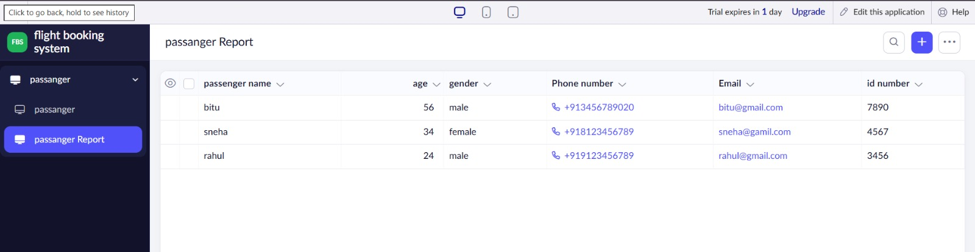

Result:
Flight booking system successfully stores and displays booking details in table format.

